EASTSIDE SURGERY 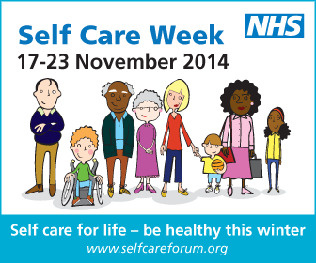
Be prepared this winter –take care of those tiresome winter ailments
Did you know that it is usual for adults to have two to four colds a year while children are likely to have three to eight as their immune system is more susceptible to viral infections? That’s why, during winter, when seasonal illnesses are more frequent, it is important to take extra measures to stay well.
As part of Self Care Week 2014, we at EASTSIDE SURGERY are encouraging people to choose healthy lifestyle options that will impact positively on their physical health, mental wellbeing and self esteem. Help to maintain health and ward off illness by eating sensibly, stop smoking, drinking in moderation and taking regular exercise.
However, if you do fall sick with a winter ailment, we want to make sure you are able to look after yourself at home safely. Here are a few facts about colds and flu:
- Most cold and flu symptoms can be treated safely at home without the need for a GP;
- Coughs can last three to four weeks;
- In adults and older children, cold symptoms last for about a week and a half, and in younger children for up to two weeks. Symptoms are usually worst in the first two to three days, before they gradually start to improve.
- You can catch a cold by either breathing in droplets of fluid containing the cold virus (when someone sneezes), or by touching something that someone has sneezed on, and then touching our mouth or nose.
- Paracetamol, ibuprofen or aspirin can help reduce the symptoms of a cold. Avoid giving aspirin to children under the age of 16 and follow the manufacturer’s instructions. Talk to your pharmacist about supplements that may help ease your symptoms.
- Most colds are not serious and get better by themselves. Contact your GP surgery for if you develop a high temperature (above 39°C or 102.2°F), which can be a sign of a more serious type of infection;
- Most colds get better on their own without treatment, antibiotics are ineffective for treating the common cold and may cause side effects.
- Your sore throat is likely to get better within 3 to 7 days (and a maximum of 2 weeks) without the need for treatment by a health professional. Most sore throats last for an average of eight days.

